

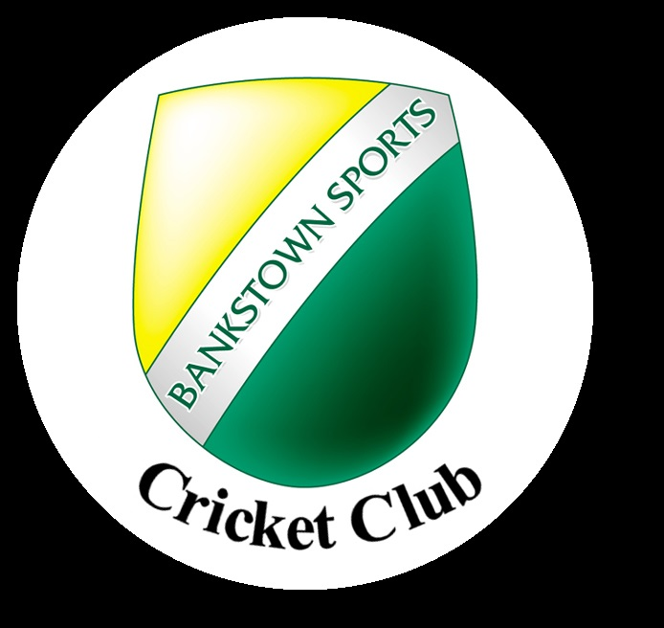

***AT STUMPS***

**ANNUAL REPORT**

**2022 – 2023**

[**www.bscc.org.au**](http://www.bscc.org.au)

[**facebook.com/BankstownSportsCC**](https://www.facebook.com/BankstownSportsCC)

[**instagram.com/bankstownsportscricketclub**](https://www.instagram.com/bankstownsportscricketclub/)





Macintosh HD:Users:kirstycordingley:Desktop:Bankstown-Sports-Logo.png**Would like to thank the following businesses who proudly supported the Bankstown Sports Cricket Club throughout the 2022/23 competition.**





***See you all next Season***

